# Writing Assignment – Results Memo (brief 2-page written (plus plots, pseudocode, and C program-listing))

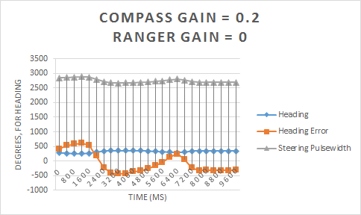

With the first set of data points, beginning with a compass gain of 0.2 and the ranger gain set to 0, the heading and the ranger values both stabilize and remain relatively linear. The heading error also stabilizes after approximately 8000ms. The steering pulsewidth is also very linear, while the heading error is shakier.

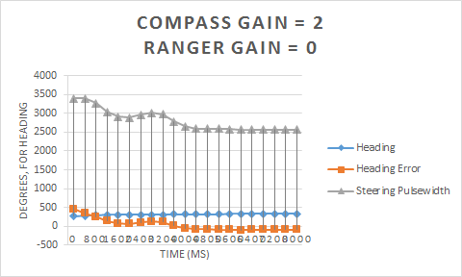

With a compass gain of 2 and a ranger gain of 0, the heading stabilizes in a more linear fashion than compared to the previous graph. The heading error also stabilizes after around 5600ms, 2400ms shorter than the prior entry of 8000ms. The steering pulsewidth also becomes slightly shaky and the heading error more linear, the vice versa of the previous diagram.

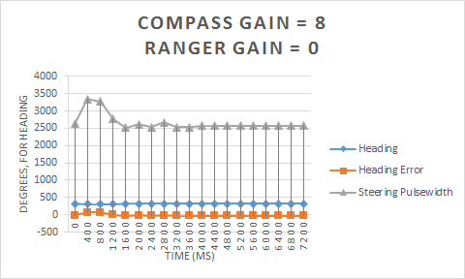

The trends shown in the prior two graphs continue, where the heading and heading error are almost exactly a straight line while steering pulsewidth is even more shaky that before, both stabilizing by 1200ms after starting. Whenever a big jump occurs on the graphs, that's when the car notices an obstacle and wants to make a hard turn. The higher the compass gain, the quicker we stabilize every time the car runs.

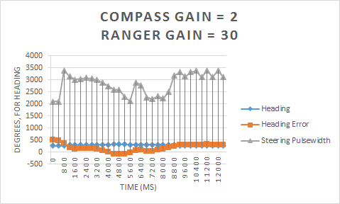

Now, with two tests to determine what effect the ranger gain has on the car, the compass gain was set to 2 and the ranger gain set to 30. The steering pulsewidth here has many large jumps that occur when the ranger detects an object, and forces the car to quickly adjust its steering pulsewidth. The car quickly turns away, introducing more heading error. After the object is no longer an issue, the car resumes its course to correct for the heading.

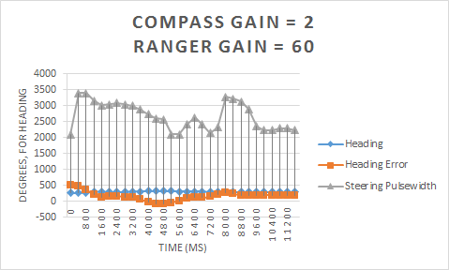

With a larger ranger gain, the adjustments are much more sudden when an object is detected. This creates a large error in the heading as the car swerves to avoid the wall. The steering eventually stabilizes towards the desired heading, though it fluctuates much more than using lower ranger gains. The heading error is almost identical to the other graph, though it adjusts more quickly.

In each of these graphs, the heading takes a little while before getting to the final result before stabilizing.

Meanwhile, when we introduce a ranger gain, we have a lot more fluctuation

The pulsewidth doesn't really do much.

**Analysis of the plots should explain what is happening and why.**

**Significant features on the plots should also be noted and explained.**

**Include a discussion of how the code performs the desired control by adjusting the steering to correct the heading error.**

The steering pulsewidth is a function of the compass_adj and ranger_adj variables. The compass_adj steers the car towards a desired heading by subtracting the current measured heading from the current heading. This adjusts the pulsewidth with a specified compass gain to direct the steering. range_adj has a much higher gain constant, and gradually adjusts the steering as the car approaches an object to avoid a collision. The closer the car gets to an object, the more it will adjust the steering. The range_adj variable is intentionally larger than compass_adj to force the car to avoid an object, even over adjusting to the desired heading. Once an object has been successfully avoided, range_adj goes to 0 and compass_adj will slowly adjust the car back to its desired heading.

**Include a complete commented listing of the C code; printed with a single spaced Courier font, 10 points, left justified, with proper indenting.**